Press January 2018
For Immediate Release Chantelle Fandino
Texworld USA- Winter 2018 Chantelle.Fandino@usa.messefrankfurt.com
Javits Convention Center www.messefrankfurt.com
January 22-24, 2018 www.texworldusa.com

Winter 2018 edition of Texworld USA and Apparel Sourcing USA breaks exhibitor and attendee records as the show expands its sourcing platform for fashion retail decision makers, buyers, designers and suppliers from around the world
New Explore the Floor series allowed attendees to tour the show floor with industry experts and learn more about exhibitors and their products
Show highlights included educational seminars, trend display area and preview of Spring/Summer 2019 color and textiles
New York City – The Winter 2018 editions of Texworld USA and Apparel Sourcing USA opened their doors to exhibitors and visitors alike on Monday, January 22nd at the Javits Center. Over three days, a wide range of international suppliers from around the globe showcased textiles, trims, accessories, manufacturing and private label development services and finished apparel for industry buyers, designers and experts.
Texworld USA and Apparel Sourcing USA Winter 2018 featured a record-breaking 371 exhibitors representing 14 countries and over 4,000 visitors. The show showcased textiles with innovative structures, material mixes and surprising color palettes across 14 product categories. Show attendees were able to view the latest textile trends, materials, fabrics and more with an exclusive opportunity to network and meet designers and suppliers from around the world while taking advantage of complimentary educational seminars.
Exhibitor, Global Textile “Our company has been to other trade shows and this is the most planned and organized. The visitors are more focused and know what they want, know what they like, and it makes for a great experience. We are doing great business and are able to find exactly what the US market wants”.
“As organizers, we recognize that our responsibilties extend far beyond providing a space for the industry to do business here in New York City. We believe in building a true industry event that unites the best talent from the industry with access to education and valuable resources, as well as a chance for our vibrant community to connect and exchange ideas. We are also aware of the changing fashion ecosystem. Texworld USA and Apparel Sourcing are dedicated to contributing to the fashion industry worldwide,” said Jennifer Bacon, Show Director, Fashion & Apparel.

Lenzing Fiber’s Educational Series returns to bring attendees the latest information within the industry
Texworld‘s educational seminar series, organized by Lenzing Fibers returned for Winter 2018 with sessions hosted by curated panels of industry experts discussing the global textile and sourcing landscape including sustainable solutions and the circular economy. Featured discussions were led by Sourcing Journal, Eileen Fisher, Trend Council and NSF International. Textile Talks were also a continued success at this year’s show led by StartUp FASHION, Lenzing Fibers, Fashionindex, BF+DA and more.
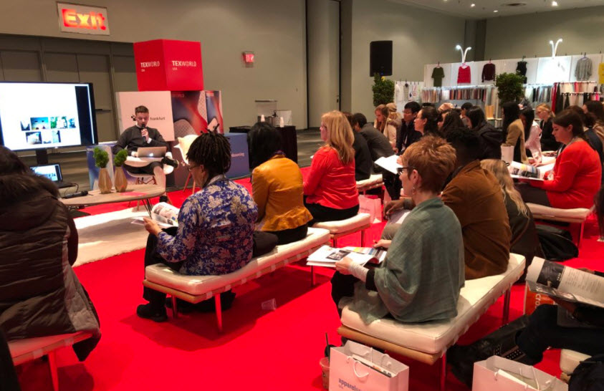
Texworld Art Director, Louis Germin discusses Spring/ Summer 2019 trends to attendees.

Texworld Trend Showcase explored the latest designs trends for the upcoming season
Texworld’s USA Trend Showcase returned curated by Texworld’s Art Directors, Louis Gerin and Gregory Lamaud. Together they brought their vision and expertise for the upcoming season. Attendees were inspired as the trend display area featured fabrics from exhibitors at the show. Visitors also had the opportunity to take a peek at the newest colors and textile offerings for Spring/Summer 2019.

Explore the Floor series launched this year at Texworld USA
New to the show floor, Texworld USA launched the “Explore the Floor” series featuring tours that allowed attendees to walk the show floor with seasoned industry experts in an intimate setting. With a focus on sustainable business and products, these tours allowed attendees to gain knowledge about different exhibitors and emerging trends.

Apparel Sourcing USA SPOTLIGHT: Denim
Apparel Sourcing USA Winter 2018 welcomed exhibitors specializing in womenswear, menswear, children's, and accessories, with a higlight on a true style icon - Denim. This SPOTLIGHT featured exhibitors specializing in denim and allowed attendees to gain more knowledge on how denim is evolving. Apparel Sourcing USA is a long-term joint venture partnership between Messe Frankfurt Inc. and CCPIT-TEX and provided attendees direct access to suppliers all over the globe.

Denim Dogs, An Art Installation
This year’s show featured installation Denim Dogs created by artist, Moon Heemin showcasing intricate dog sculptures made of denim. The designer considered the project as a study of animals in a very imaginative way. Additionally, it served to be an artistic interpretation in fabric and colors brought together. Garnering much hype and attention, many visitors took to social media to feature this unique installation.

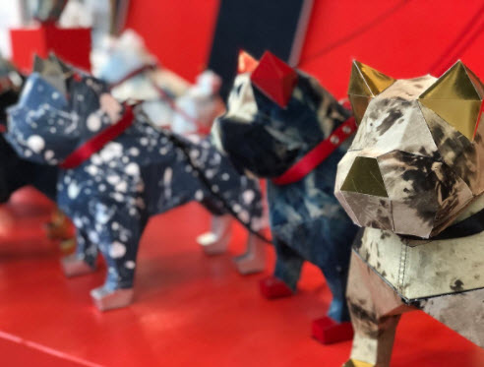
Press contact:
Gita PR
Gita Mirchandani
Tel: 917-815-3204
Email: Gita@gitapr.com

About Texworld USA
Texworld USA is the largest sourcing event on the East Coast for apparel fabric buyers, research and product development specialists, designers, merchandisers and overseas sourcing professionals. This international business platform offers a wide product range covering the entire fabric spectrum. From casual cotton to function fabrics and sophisticated knits to intricate laces, season-to-season attendees discover textiles of innovative structures, material mixes and surprising color palettes.

For more information, please visit www.texworldusa.com.

About Messe Frankfurt
Messe Frankfurt is the world’s largest trade fair, congress and event organiser with its own exhibition grounds. The Group employs more than 2,300 people at around 30 locations around the globe. With boundless passion and a wealth of experience, we have been active in the international trade fair business, both in Frankfurt and worldwide, for some 800 years. From automotive to logistics, from textiles to music, from energy efficiency to security, from homes to beauty – Messe Frankfurt’s programme of trade fairs, congresses and other events is extremely comprehensive. And the quality of our events meets the very highest standards.

With 366,000 square metres of exhibition space in ten different halls and over 96,000 square metres of outdoor exhibition space, it is the ideal venue for any event.

For more information, please visit our website at: www.messefrankfurt.com.

